**CHANDIGARH UNIVERSITY**

UNIVERSITY INSTITUTE OF ENGINEERING

**DEPARTMENT OF COMPUTER SCIENCE & ENGINEERING**



|  |  |
| --- | --- |
| **Submitted By:                                                                          Submitted To:**  Yash Gupta Monika(E12802) | |
| **Subject Name** | Design Analysis and Algorithm |
| **Subject Code** | 20CSP_312 |
| **Branch** | CSE |
| **Semester** | 5th |

**LAB -INDEX**

|  |  |  |  |  |  |  |  |
| --- | --- | --- | --- | --- | --- | --- | --- |
| **Sr.No** | **Program** | **Date** | **Evaluation** | | | | **Sign** |
| **LW(12)** | **VV(8)** | **FW(10)** | **Total (30)** |
|  |  |  |  |  |  |  |  |
|  |  |  |  |  |  |  |  |
|  |  |  |  |  |  |  |  |
|  |  |  |  |  |  |  |  |
|  |  |  |  |  |  |  |  |
|  |  |  |  |  |  |  |  |
|  |  |  |  |  |  |  |  |
|  |  |  |  |  |  |  |  |
|  |  |  |  |  |  |  |  |
|  |  |  |  |  |  |  |  |

**Experiment 1**

**1. Aim/Overview of the practical:**

***Code and analyse to compute the greatest common divisor (GCD) of two numbers.***

**2. Algorithm:**

Step 1: Let a, b be the two numbers

Step 2: a mod b = R

Step 3: Let a = b and b = R

Step 4: Repeat Steps 2 and 3 until a mod b is greater than 0

Step 5: GCD = b

Step 6: Finish

**3. Steps for experiment/practical/Code:**

#include <iostream>

using namespace std;

int gcd (int x, int y)

{

if (y == 0)

return a;

return gcd(y, x % y);

}

int main()

{

int x = 98, y = 56;

cout<<"GCD of "<<x<<" and "<<y<<" is "<<gcd(x, y);

return 0;

}

**4. Result/Output/Writing Summary:**

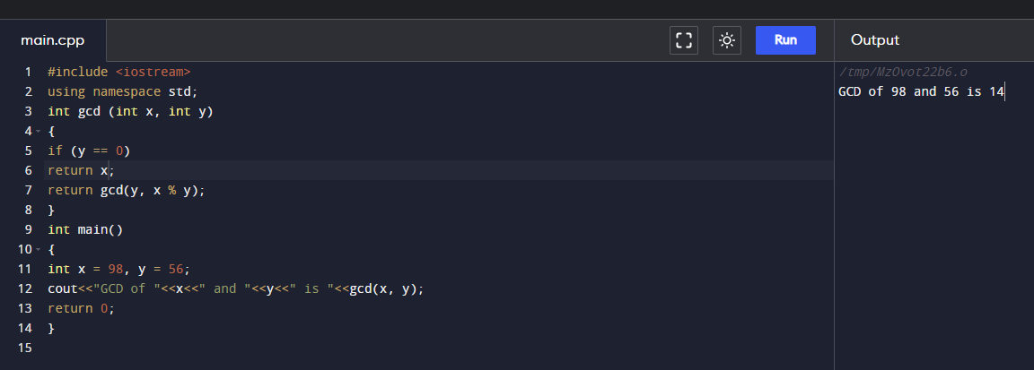

**5. Observations/Discussions/ Complexity Analysis:**

Time complexity of finding GCD of two number using Euclidean method is O(log n).

**6. Learning outcomes (What I have learnt):**

**1.** To know how Euclidean algorithm works.

**2.** To learn how to use recursion for solving problems.

**Evaluation Grid (To be created as per the SOP and Assessment guidelines by the faculty):**

|  |  |  |  |
| --- | --- | --- | --- |
| Sr. No. | Parameters | Marks Obtained | Maximum Marks |
| 1. |  |  |  |
| 2. |  |  |  |
| 3. |  |  |  |
|  |  |  |  |